University of the Punjab

PU-CIT

Project: E-commerce Store using
(HTML, CSS & JS)
Roll#: BAIF25M026

Introduction,
The MHD E-Commerce Store is a simple, responsive web application designed for showcasing and selling digital accessories such as headsets, microphones, and USB devices. Built using fundamental web technologies (HTML, CSS, and JavaScript), this project serves as a prototype for an online store. It includes user registration, product browsing, contact information, and a basic dashboard for order management. The site features a modern, gradient-based design with theme toggling (dark/light modes) and fade-in animations for enhanced user experience.
The backend integration is minimal, using a Google Apps Script to handle form submissions for user registrations, which are stored in a Google Sheet (exported as MHD Record for reference). Orders are simulated via JavaScript alerts and are not persisted.
Goals:
- Intuitive product exploration.
- Basic e-commerce features.
- Responsive design.

Key Features
- Registration with Google Sheets integration.
- Product catalog with order alerts.
- Dark/light theme toggle.
- Navigation: Home, Products, Contact, Dashboard.
- Fade-in animations and hover effects.

Technologies Used

HTML
Structures pages with semantic elements (e.g., <header>, <main>). Defines forms, images, and layouts.

CSS
Handles styling: gradients, transitions, flexbox/grid for responsiveness, theme classes, animations (e.g., @keyframes fadein).

JavaScript
Adds interactivity: theme toggle, form submission (Fetch API to Google Script), order alerts via event listeners.

Project Structure
- index.html: Registration.
- home.html: Landing.
- products.html: Catalog.
- contact.html: Contacts.
- dashboard.html: Orders/stats.
- stylesheet.css: Styles.
- script.js: Logic.
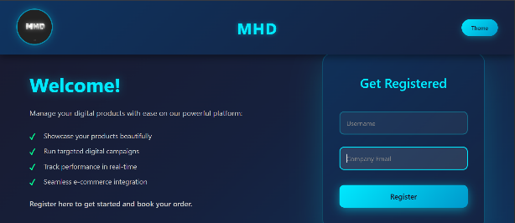
- MHD Record.xlsx: Sample registration data.

Pages and Functionality

Index (index.html) - Registration
Purpose: User sign-up entry.
Functionality: Welcome text + form (username/email). JS submits to Google Script, redirects to home.

Home (home.html)
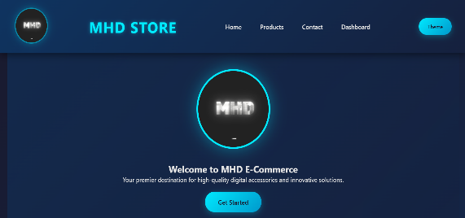
Purpose: Introduce store.
Functionality: Hero with logo/button, about section, features list. Navigation + theme toggle. CSS fade-in.

Products (products.html)
Purpose: Browse products.
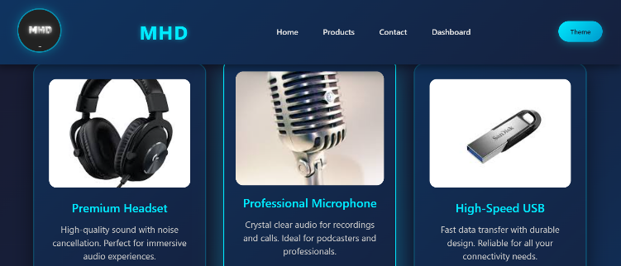
Functionality: Grid cards with images/prices. "Order Now" buttons trigger JS alerts.

Contact (contact.html)
Purpose: Reach out options.
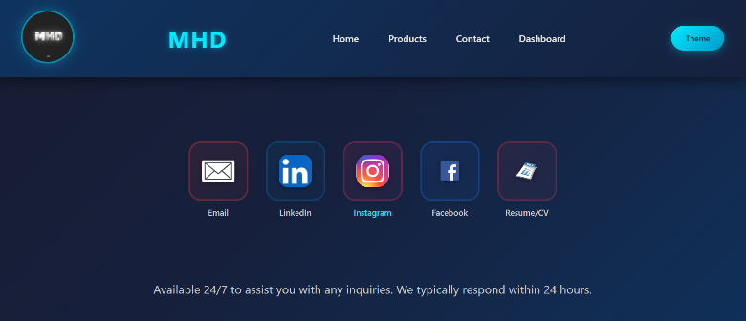
Functionality: Icon links (email, socials, CV). CSS hover effects.

Dashboard (dashboard.html)
Purpose: Manage orders.
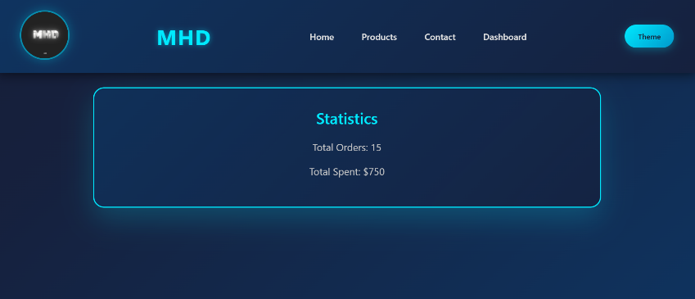
Functionality: Static sections for orders, settings, stats. Edit button links to index.

Data Handling
- Registrations: To Google Sheet (sample in XLSX).
- Orders: Alerts only.

How to Run
- Open index.html in browser.
- Navigate/test features.
- Internet needed for registration.

